**Hotel Booking UI Kit**

Hotel booking project after extracting new_motel folder. You can do this step for both platforms windows and mac os:

1. Extract Folder in your system.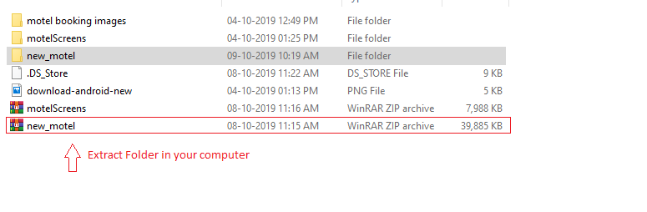

2. Install Android studio or Visual studio code.

3. Open new_motel folder in Android studio or Visual studio code.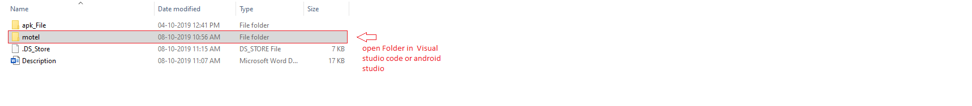

4. Add Flutter setup environment in Android studio or Visual studio code.

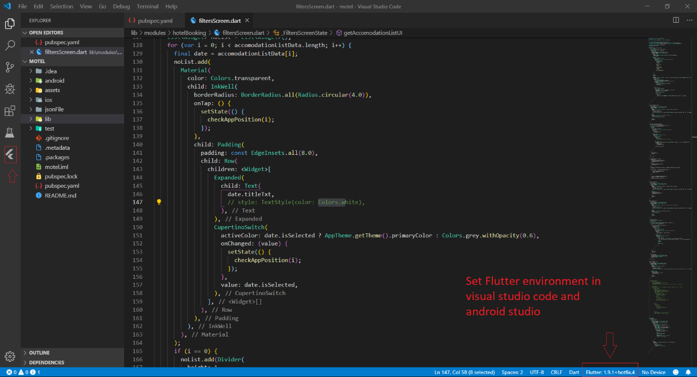

5. Connect your devices or emulator.

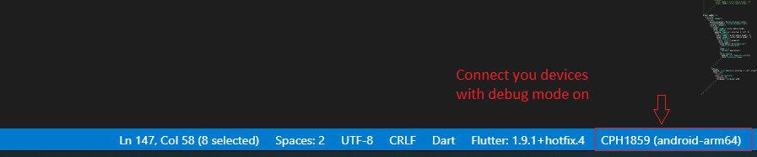

6. Fetch Data from pubsec.yaml file.



7. Run code.



Now you can get your output in your devices.

**Description:**

* Hotel booking UI Kit contains 30+ Screens with a different type of UI component; this kit can save your time to code all Front end layout and its Easy to implement with your code!.one the main thing is Its support both platforms Android and iOS.
* Hotel booking UI kit will give all most all the details required for a hotel booking application which includes person detail, room images, animosities details, etc. Everything was made with a detail-oriented style and followed by today’s web trends. Clean coded & Layers are well-organized, carefully named, and grouped.
* Change text, colours and graphics, add or place photos. Customize every element as much, or as little as you want. Customize elements (easy to edit)
* 100% free fonts Perfect pixel (high-quality design) Very clean and cool UI Free updates.

**Hotel Booking flutter UI Kit Features:**

* Support Android App (Mobil/Tablet) and iOS/iPad
* Dart Language
* UI/UX design from industry experts
* Smooth Transition Effects
* Font Awesome & Material Icons
* Work Sans Font
* Mobile and Tablet Support
* Responsive design for all device
* Animation Controller
* Black & White Theme
* Complete hotels booking module
* Sign in, sign up, reset the password, setting profile

**Hotel Booking Description:**

Hotel booking– is Flutter mobile/tablet app templates has made with reusable components and easily build apps in a short time.

Hotel booking provides you a solution to reduce your time and cost for creating a unique UI/UX travel booking mobile application template. If you already want to start your project-related with hotel booking a mobile/tablet application for android and iOS, just try it now.